Instructions for using the NYSGA database on Excel

There are two files which need to be used together, Through2006.xlsx and GETemplate.docx. There is a little manipulation required, but the result is a found set of placemarks showing field trip routes and locations of stops and views from 1956 to 2006.

All the data exists in column K, labeled "kml out5" on the table, which you will use to export it, but the other columns are there so that users can use the Table attributes of Excel to narrow their searches effectively.

Location Limited Example: You wish to explore stops in the area of Hamilton, NY.

1. Use Google Earth to find Hamilton's coordinates: 42.82, -75.54.

2. You wish to limit your search to 15 miles in both the N-S and E-W direction. Go to the worksheet labeled "Calculate Limits" and put these numbers into the correct cells. This tells you the numbers to put into the Latitude and Longitude search fields of the Table of Data.

3. Click on the filter icon at the top of the column named "Latitude" and then go down to where it says, "Choose One" and select "Between" and then put in the numbers. Do the same for "Longitude." This gives you 127 placemarks in column K.

4. Copy and paste them into the space near the bottom of the Word file, in between the lines of red type. That file is 10 pages long before you paste, 90 pages long after you paste.
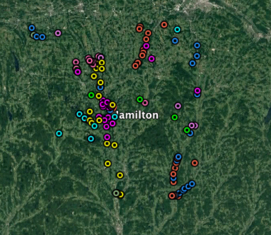

5.Save this file as a .txt file to your desktop, using any name other than GETemplate. (The encoding should be Unicode 7 UTF-8.)

6. Change the suffix from .txt to .kml and then open it in Google Earth. You should get something like:

Field Trip Limited Example: You wish to follow the routes Ernie Muller took during the 1964 NYSGA meeting in Syracuse.

1. Use the filter for "year", go down to where it says, "Choose One" and pick "Equals", and then type in "1964".

2. Next use the filter for "leader" and type "Muller" in the search field. This should result in 106 records from trips B and D.

3. Copy the cells under K, and past these results into the Word document, at the bottom, between the lines typed in red.

4. Save this as a text file with your own name, perhaps, "Muller1964.txt".
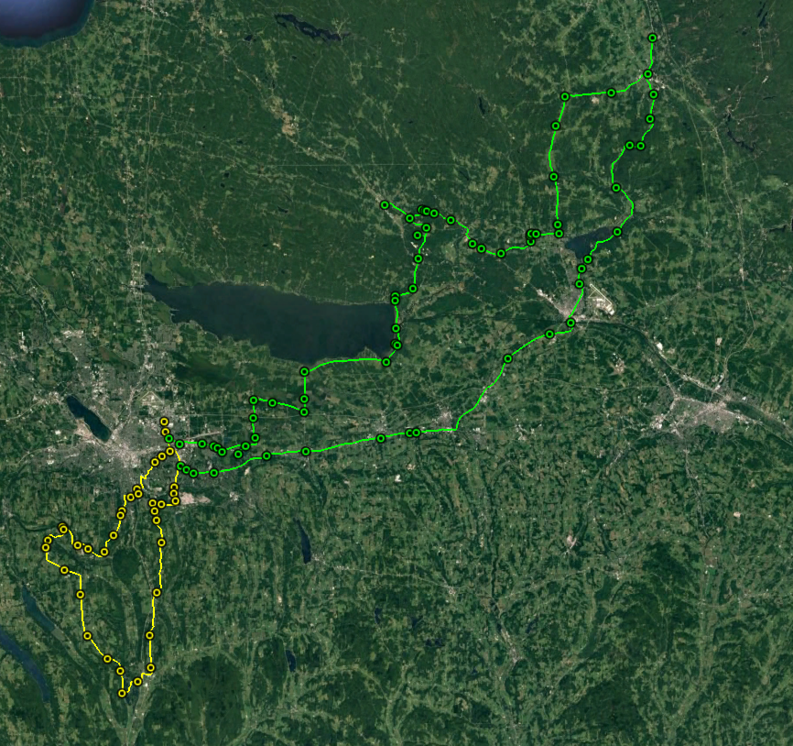

5. Change the .txt to .kml and open it in Google Earth. You should get something like:

Normal text searches in column K result in 103 hits for "esker," 50 hits for "phlogopite," 183 for "archean" and 16 for "sewage" as many sub-disciplines of geology are represented.

There are a few convenient search terms which may help some users:

Any fossil name which was italicized in the description was given <i> </i> tags, so searching column K for <i> will result in the 553 placemarks where fossils were identified at the species level. The <em> tag was used for other italicized words, such as living plant species, etc. <sub> find any subscripts and <sup> any superscripts, so to find carbon dioxide, search for CO<sub/2<sub>, and a fold generation can be found with F<sub>1.

Quadrangle Names are found by searching in column I, called Quad Name in the table. These are USGS 7.5 minute quadrangles. Often geologists work in areas restricted to certain quads.

